Project Design Phase-II
Technology Stack (Architecture & Stack)

Date | 27 February 2026
Team ID | TSK841298
Project Name | HematoVision: Advanced Blood Cell Classification Using Transfer Learning
Maximum Marks | 4 Marks

Technical Architecture:
The Deliverable shall include the architectural diagram as below and the information as per the table1 & table 2
Example: Order processing during pandemics for offline mode
Reference: https://developer.ibm.com/patterns/ai-powered-backend-system-for-order-processing-during-pandemics/
Guidelines:
Include all the processes (As an application logic / Technology Block)
Provide infrastructural demarcation (Local / Cloud)
Indicate external interfaces (third party API’s etc.)
Indicate Data Storage components / services
Indicate interface to machine learning models (if applicable)
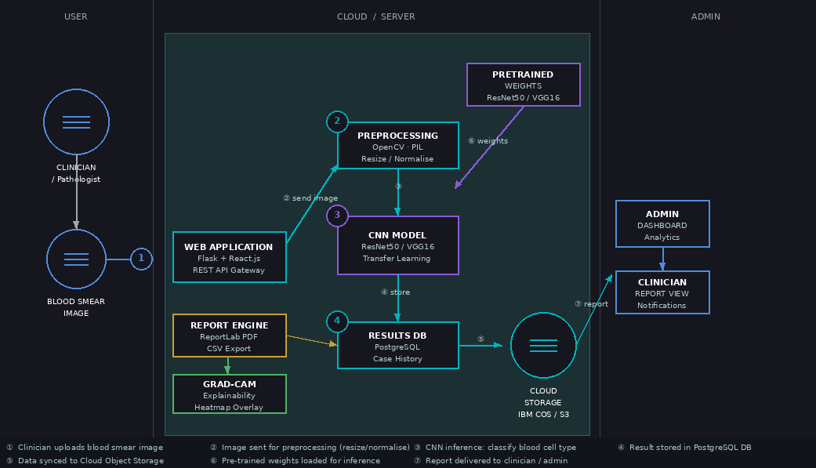

Table-1 : Components & Technologies:
S.No | Component | Description | Technology
- 1 | User Interface | Web-based portal for clinicians and pathologists to upload blood smear images, view classification results with confidence scores, download PDF/CSV diagnostic reports, and access case history dashboard. | React.js, HTML5, CSS3, Axios, Chart.js
- 2 | Application Logic-1 (Image Upload & Validation) | Handles blood smear image upload (JPG/PNG/TIFF up to 10 MB), validates file format and resolution, queues image for preprocessing pipeline, and returns upload confirmation to UI. | Python (Flask), REST API, Werkzeug
- 3 | Application Logic-2 (Preprocessing) | Preprocesses uploaded blood smear image: resizes to 224×224 pixels, normalises pixel values to [0,1] range, applies colour augmentation. Prepares tensor input for CNN inference. | Python, OpenCV 4.x, PIL/Pillow, NumPy
- 4 | Application Logic-3 (CNN Inference) | Runs transfer learning CNN model (ResNet50/VGG16 fine-tuned on BCCD dataset) to classify blood cell type (RBC, WBC, Platelet, Blast) and returns predicted class with confidence score. Generates Grad-CAM heatmap for explainability. | Python, TensorFlow 2.x, Keras, Grad-CAM
- 5 | Database | Relational database storing user profiles, classification results, case history, model metadata, audit logs. ACID-compliant with indexed queries for fast retrieval of historical cases. | PostgreSQL 14, SQLAlchemy ORM
- 6 | Cloud Database | Cloud-hosted managed database for high availability, automated backups, point-in-time recovery, and cross-region replication. Stores all production classification results and reports. | IBM Db2 on Cloud / AWS RDS PostgreSQL
- 7 | File Storage | Stores uploaded blood smear images, generated PDF/CSV reports, and Grad-CAM heatmap overlays. Files encrypted at rest with AES-256, versioned, and replicated across two availability zones. | IBM Cloud Object Storage / AWS S3
- 8 | External API-1 (Pre-trained Model Weights) | Loads ImageNet pre-trained ResNet50/VGG16 weights for transfer learning fine-tuning on the BCCD blood cell classification dataset. Enables fast convergence with limited labelled data. | TensorFlow Hub, Keras Applications API
- 9 | External API-2 (Email Notification) | Sends automated email notifications to clinicians when their diagnostic report is ready, and alerts lab managers and administrators when low-confidence predictions (<70%) require mandatory human review. | SendGrid Email API / SMTP (Flask-Mail)
- 10 | Machine Learning Model | Transfer learning CNN fine-tuned on the BCCD (Blood Cell Count and Detection) dataset. Architecture: ResNet50 base + custom classification head. Achieves ≥90% accuracy on 4-class blood cell classification. Grad-CAM overlay highlights prediction region on original image for clinical explainability. | TensorFlow 2.x, Keras, ResNet50, VGG16, Grad-CAM, scikit-learn
- 11 | Infrastructure (Server / Cloud) | Application deployed on cloud using Docker containers orchestrated with Kubernetes for auto-scaling.  Local Dev: 16 GB RAM, NVIDIA GPU (CUDA 11+), Ubuntu 22.04  Cloud: IBM Cloud IKS / AWS EKS (GPU-enabled nodes, NVIDIA T4) | Docker, Kubernetes (IBM IKS / AWS EKS), Nginx, Gunicorn, CUDA

Table-2: Application Characteristics:
S.No | Characteristics | Description | Technology
- 1 | Open-Source Frameworks | TensorFlow/Keras for CNN model training and inference. Flask for RESTful API backend. React.js for responsive web frontend. OpenCV and PIL for image preprocessing. ReportLab for PDF report generation. PostgreSQL as relational database. Pandas for CSV export and data analysis. | TensorFlow 2.x, Keras, Flask, React.js, OpenCV 4.x, PIL, ReportLab, PostgreSQL, Pandas
- 2 | Security Implementations | AES-256 encryption for all patient blood smear images and reports at rest. TLS 1.3 for all data in transit. JWT-based authentication with 30-minute session expiry. Role-Based Access Control (RBAC) restricting data access by user role (Clinician / Pathologist / Admin). HIPAA and GDPR compliance. OWASP Top-10 mitigations applied. SQL injection prevention via ORM parameterised queries. | AES-256, TLS 1.3, JWT, RBAC, OWASP Top-10, HIPAA/GDPR, SQLAlchemy ORM
- 3 | Scalable Architecture | 3-tier architecture: Presentation (React.js SPA), Application (Flask microservices), Data (PostgreSQL + IBM COS). CNN inference deployed as an independent Docker microservice enabling independent horizontal scaling. Kubernetes auto-scales inference pods based on GPU utilisation. Stateless REST API allows multiple application server instances behind a load balancer. | Docker, Kubernetes (IKS/EKS), 3-Tier Microservices, Stateless REST API
- 4 | Availability | 99.5% uptime SLA. Nginx load balancer distributes HTTP traffic across multiple Flask application instances. PostgreSQL synchronous read replicas ensure database availability during primary failover. IBM Cloud Object Storage replicates images across two availability zones. Planned maintenance windows restricted to 02:00–04:00 local time. Health check endpoints enable Kubernetes liveness/readiness probes. | Nginx Load Balancer, PostgreSQL Replication, Multi-AZ Object Storage, Kubernetes Health Probes
- 5 | Performance | Single blood smear image CNN inference: <5 seconds under standard load. Batch processing of 50 images via Celery async queue: <3 minutes. Web portal initial load: <2 seconds on ≥10 Mbps connection. Redis caching for repeated case lookups reduces DB queries by 60%. GPU-accelerated inference (NVIDIA CUDA) enables 10× faster model forward pass vs CPU-only. | Redis Cache, Celery Async Queue, NVIDIA CUDA GPU, Nginx, Gunicorn (4 workers)

References:
https://c4model.com/
https://developer.ibm.com/patterns/online-order-processing-system-during-pandemic/
https://www.ibm.com/cloud/architecture
https://aws.amazon.com/architecture
https://medium.com/the-internal-startup/how-to-draw-useful-technical-architecture-diagrams-2d20c9fda90d

